CSS 475 A Database Systems

Homework 2 (30 possible points) [6% of final grade]

1. (8 points) Design an ER diagram for keeping track of information about votes taken in the U.S. House of Representatives during the current two-year congressional session. The database needs to keep track of each U.S. state’s name (e.g., ‘Texas’, ‘New York’, ‘California’) and include the region of the state (whose domain is {‘Northeast’, ‘Midwest’, ‘Southeast’, ‘Southwest’, ‘West’}). Each congress person in the House of Representative is described by his or her name, plus the district represented, the start date when the congressperson was first elected, and the political party to which he or she belongs (whose domain is {‘Republican’, ‘Democrat’, “Independent’, ‘Other’}). The database keeps track of each bill (i.e., proposed law), including the bill name, the date of vote on the bill, whether the bill passed or failed (whose domain is {‘Yes’, ‘No’}), and the sponsor (the congressperson(s) who sponsored – that is, proposed – the bill). The database also keeps track of how each congressperson voted on each bill (domain of vote attribute is {‘Yes’, ‘No’, ‘Abstain’, ‘Absent’}).
Additional information:
- There are 435 congresspersons in the U.S. House of Representatives.
- States have between one and 52 representatives.
- M represents number of bills during the 2-year session.
Draw an ER diagram for this application. Be sure to indicate the various attributes of each entity and relationship set; also specify the key and structural constraints for each relationship set. If you make any assumptions beyond everything stated above, explain clearly in your submission.
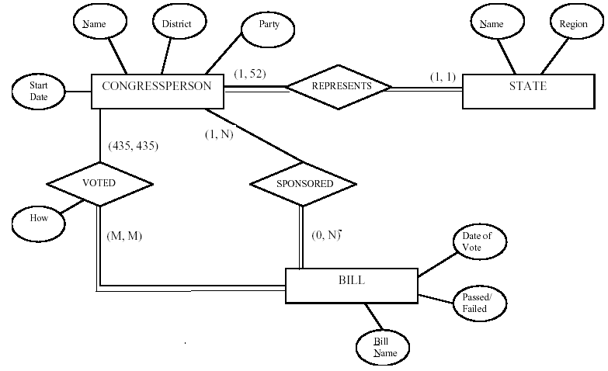
2. (3 points) Consider the ER diagram in Figure 1. Assume that an employee may work in up to two departments or may not be assigned to any department. Assume that each department must have one and may have up to three phone numbers. Additionally we have the following additional assumptions:
Each department can have anywhere between 1 and 10 employees.
Each phone is used by one, and only one, department.
Each phone is assigned to at least one employee, and may be assigned to up to 10 employees.
Each employee is assigned at least one, but no more than 6 phones.
Supply (min, max) constraints on this diagram. If you make any assumptions beyond everything stated above, explain clearly in your submission.
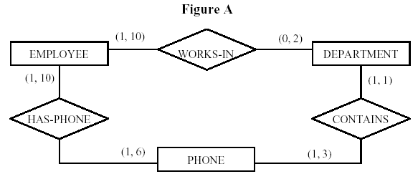

3. (5 points) Suppose that each of the following update operations is applied directly to the database shown in Figure 2. Discuss all integrity constraints violated by each operation, if any, and at least 2 different ways of enforcing these constraints.

- Insert <Robert', 'F', 'Scott', '943775543', '1972-06-21', '2365 Newcastle Rd, Bellaire, TX', M, 58000, '888665555',1> into EMPLOYEE.
- Insert <'ProductA', 4, 'Bellaire', 2> into PROJECT.
- Insert <'Production', 4, '943775543', '2007-10-01'> into DEPARTMENT.
- Insert <'677678989', NULL, '40.0'> into WORKS_ON.
- Insert <'453453453', 'John', M, '1990-12-12', 'spouse'> into DEPENDENT.
- Delete the WORKS_ON tuples with Essn = '333445555'.
- Delete the EMPLOYEE tuple with Ssn = '987654321'.
- Delete the PROJECT tuple with Pname = 'ProductX'.
- Modify the Mgr_ssn and Mgr_start_date of the DEPARTMENT tuple with Dnumber = 5 to '123456789' and '2007-10-01', respectively.
- Modify the Super_ssn attribute of the EMPLOYEE tuple with Ssn = '999887777' to '943775543'.
(a) No constraint violations.

(b) Violates referential integrity because DNUM=2 and there is no tuple in the DEPARTMENT relation with DNUMBER=2. We may enforce the constraint by: (i) rejecting the insertion of the new PROJECT tuple, (ii) changing the value of DNUM in the new
PROJECT tuple to an existing DNUMBER value in the DEPARTMENT relation, or (iii)
inserting a new DEPARTMENT tuple with DNUMBER=2.

(c) Violates both the key constraint and referential integrity. Violates the key constraint
because there already exists a DEPARTMENT tuple with DNUMBER=4. We may enforce
this constraint by: (i) rejecting the insertion, or (ii) changing the value of DNUMBER
in the new DEPARTMENT tuple to a value that does not violate the key constraint. Violates
referential integrity because MGRSSN='943775543' and there is no tuple in the
EMPLOYEE relation with SSN='943775543'. We may enforce the constraint by: (i)
rejecting the insertion, (ii) changing the value of MGRSSN to an existing SSN value in
EMPLOYEE, or (iii) inserting a new EMPLOYEE tuple with SSN='943775543'.

(d) Violates both the entity integrity and referential integrity. Violates entity integrity
because PNO, which is part of the primary key of WORKS_ON, is null. We may enforce
this constraint by: (i) rejecting the insertion, or (ii) changing the value of PNO in the
new WORKS_ON tuple to a value of PNUMBER that exists in the PROJECT relation.
Violates referential integrity because ESSN='677678989' and there is no tuple in the
EMPLOYEE relation with SSN='677678989'. We may enforce the constraint by: (i)
rejecting the insertion, (ii) changing the value of ESSN to an existing SSN value in
EMPLOYEE, or (iii) inserting a new EMPLOYEE tuple with SSN='677678989'.

(e) No constraint violations.

(f) No constraint violations.

(g) Violates referential integrity because several tuples exist in the WORKS_ON,
DEPENDENT, DEPARTMENT, and EMPLOYEE relations that reference the tuple being
deleted from EMPLOYEE. We may enforce the constraint by: (i) rejecting the deletion, or
(ii) deleting all tuples in the WORKS_ON, DEPENDENT, DEPARTMENT, and EMPLOYEE
relations whose values for ESSN, ESSN, MGRSSN, and SUPERSSN, respectively, is equal
to'987654321'.

(h) Violates referential integrity because two tuples exist in the WORKS_ON relations that
reference the tuple being deleted from PROJECT. We may enforce the constraint by: (i)
rejecting the deletion, or (ii) deleting the tuples in the WORKS_ON relation whose value
for PNO=1 (the value for the primary key PNUMBER for the tuple being deleted from
PROJECT).

(i) No constraint violations.

(j) Violates referential integrity because the new value of SUPERSSN='943775543' and
there is no tuple in the EMPLOYEE relation with SSN='943775543'. We may enforce the
constraint by: (i) rejecting the deletion, or (ii) inserting a new EMPLOYEE tuple with
SSN='943775543'.

4. (7 points) Try to map the relational schema of Figure 3 into an ER diagram. This is part of a process known as reverse engineering, where a conceptual schema is created for an existing implemented database. State any assumptions you make.
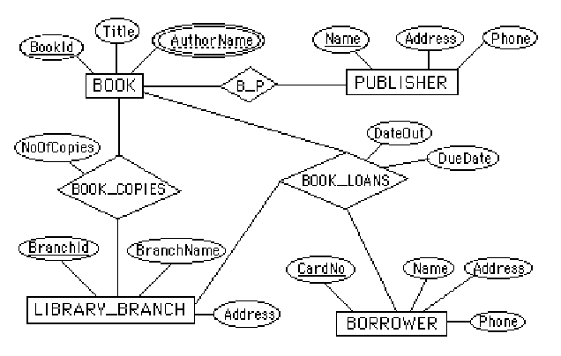

Note: We represented BOOK_AUTHORS as a multi-valued attribute of BOOK in the above
ER diagram. Alternatively, it can be represented as a weak entity type.

5. (7 points) Figure 4 shows an ER diagram for a database that can be used to keep track of transport ships and their locations for maritime authorities. Map this schema into a relational schema, and specify all primary keys and foreign keys.

